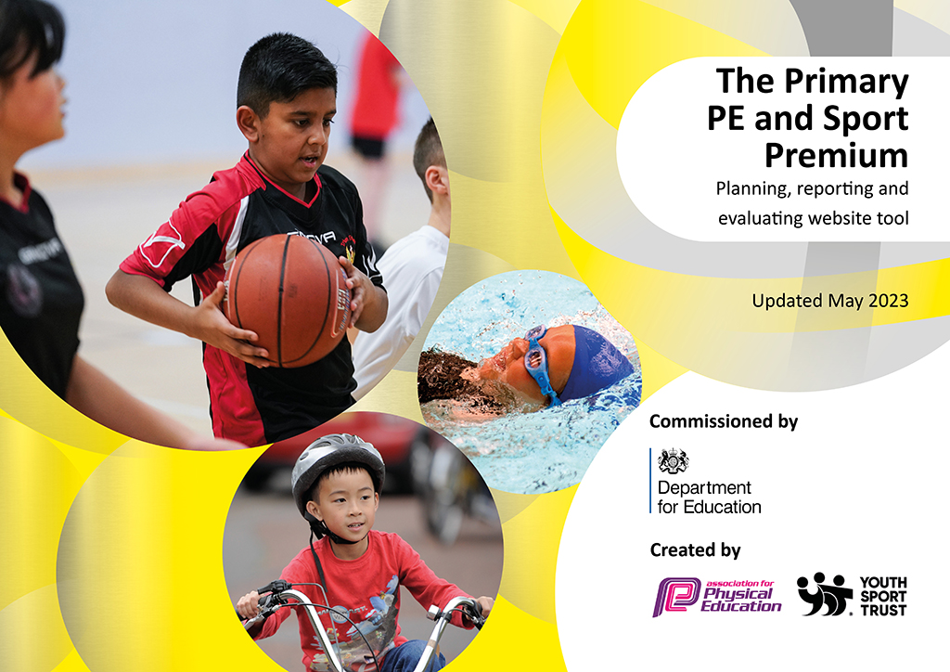
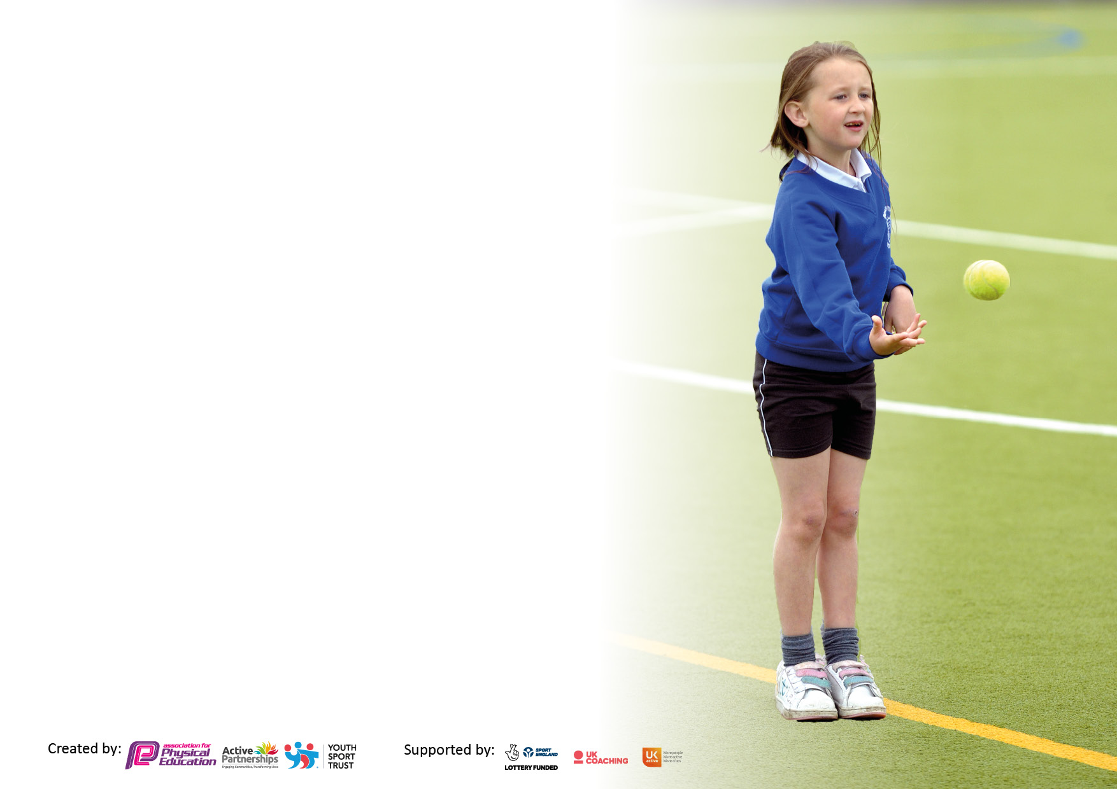

It is important that your grant is used effectively and based on school need. The Education Inspection Framework makes clear there will be a focus on ‘whether leaders and those responsible for governors all understand their respective roles and perform these in a way that enhances the effectiveness of the school’.

Under the Quality of Education Ofsted inspectors consider:
Intent - Curriculum design, coverage and appropriateness
Implementation - Curriculum delivery, Teaching (pedagogy) and Assessment
Impact - Attainment and progress

To assist schools with common transferable language this template has been developed to utilise the same three headings which should make your plans easily transferable between working documents.

Schools must use the funding to make additional and sustainable improvements to the quality of Physical Education, School Sport and Physical Activity (PESSPA) they offer. This means that you should use the Primary PE and sport premium to:

- Develop or add to the PESSPA activities that your school already offer
- Build capacity and capability within the school to ensure that improvements made now will benefit pupils joining the school in future years
- The Primary PE and sport premium should not be used to fund capital spend projects; the school’s budget should fund these.

Please visit gov.uk for the revised DfE guidance including the5keyindicatorsacrosswhichschoolsshoulddemonstrate an improvement. This document will helpyoutoreviewyourprovisionandtoreportyourspend.DfEencouragesschools to use this template as an effective way of meeting the reporting requirements of the Primary PE and Sport Premium.

We recommend you start by reflecting on the impact of current provision and reviewing the previous spend.

Schools are required to publish details of how they spend this funding, including any under-spend from 2024/2025, as well as on the impact it has on pupils’ PE and sport participation and attainment. The funding should be spent by 31st July but the DfE has stated that there will be no clawback of any unspent money so this can be carried forward into 2024/25.

We recommend regularly updating the table and publishing it on your website throughout the year. This evidences your ongoing self-evaluation of how you are using the funding to secure maximum, sustainable impact. Final copy must be posted on your website by the end of the academic year and no later than the 31st July 2023. To see an example of how to complete the table please click HERE.

Details with regard to funding
Please complete the table below.

Total amount carried over from 2023/24 | £0
Total amount allocated for 2024/25 | £17, 810
How much (if any) do you intend to carry over from this total fund into 2025/26? | £0
Swimming Data
Please report on your Swimming Data below.

Meeting national curriculum requirements for swimming and water safety.

N.B. Complete this section to your best ability. For example you might have practised safe self-rescue techniques on dry land which you can then transfer to the pool when school swimming restarts.
Due to exceptional circumstances priority should be given to ensuring that pupils can perform safe self rescue even if they do not fully meet the first two requirements of the NC programme of study
What percentage of your current Year 6 cohort swim competently, confidently and proficiently over a distance of at least 25 metres?  N.B. Even though your pupils may swim in another year please report on their attainment on leaving primary school at the end of the summer term 2023.  Please see note above | 89.6%
What percentage of your current Year 6 cohort use a range of strokes effectively [for example, front crawl, backstroke and breaststroke]?  Please see note above | 86.2%
What percentage of your current Year 6 cohort perform safe self-rescue in different water-based situations? | 93.1%
Schools can choose to use the Primary PE and sport premium to provide additional provision for swimming but this must be for activity over and above the national curriculum requirements. Have you used it in this way? | Yes/No

Action Plan and Budget Tracking
Capture your intended annual spend against the 5 key indicators. Clarify the success criteria and evidence of impact that you intend to measure to evaluate for pupils today and for the future.

Academic Year: 2024/25 | Total fund allocated: £17,810 | Date Updated: 21.07.2025
Key indicator 1: The engagement of all pupils in regular physical activity – Chief Medical Officers guidelines recommend that primary school pupils undertake at least 30 minutes of physical activity a day in school |  |  |  | Percentage of total allocation:
 |  |  |  | 25%
Intent | Implementation |  | Impact
Your school focus should be clear what you want the pupils to know and be able to do and about  what they need to learn and to  consolidate through practice: | Make sure your actions to achieve are linked to your intentions: | Funding allocated: | Evidence of impact: what do pupils now know and what can they now do? What has changed?: | Sustainability and suggested next steps:
- Educate children in the value and benefits of a healthy active lifestyle.  - Ensure our high-quality PE and school sport offer develops competent and confident movers with the aim of inspiring lifelong participation in physical activity.  - Use active lessons to increase physical activity levels and learning.  - Raise awareness of the best places to take part in sport and physical activity outside of school through virtual assemblies  - Provide opportunities for daily physical activity.  - To increase pupils’ activity levels throughout the day. | - Through PE lessons and sport, ensure our children understand the role of movement in the development of their own physical literacy, fitness and well-being.  - Develop the PE curriculum to ensure lessons link to the multi-skills approach found in our PE policy.  - Build links with local community sports clubs through our SGO.  - Develop action plan  - Purchase Resources  - Train sports leaders | £1650 | - Positive attitudes to health and well-being  - Pupil concentration, commitment, self-esteem and behaviour  - Pupils activity at lunch and break increased  - Children taking part in daily additional activities during active breaktimes  - Sports Leaders support active play across the school  - children across the school more active on a daily basis and enjoy being active  Evidence -  - Curriculum map  - PE policy  - Registers of participation  - Extra-curricular data | - Monitor physical activity levels to ensure we meet the government guidelines of at least 30 minutes a day for each child in school time.  - Monitor provision on yards and how this is helping to facilitate 30mins exercise per day  - Staff monitor children to ensure that sedentary children are encouraged to exercise during break times
Key indicator 2: The profile of PESSPA being raised across the school as a tool for whole school improvement |  |  |  | Percentage of total allocation:
 |  |  |  | 20%
Intent | Implementation |  | Impact
Your school focus should be clear what you want the pupils to know and be able to do and about  what they need to learn and to  consolidate through practice: | Make sure your actions to achieve are linked to your intentions: | Funding allocated: | Evidence of impact: what do pupils now know and what can they now do? What has changed?: | Sustainability and suggested next steps:
- Use PE and sport to enable the development of life skills that are transferred to other curriculum areas, wider school and beyond.  - Use PE and sport to develop the whole person including thinking, social and personal skills.  - Use PE teaching to aid fine and gross motor skill development, particularly for children in EYFS and KS1 with targeted intervention in KS2.  - Use sporting role models and sports leaders to engage and raise achievement.  - Ensure PE and school sport is at the heart of our school and is seen as a clear priority by staff, children and parents. This is done through assemblies, notice boards,  school social media, pupil awards.  - High quality PE lessons delivered during curriculum time.  - Monitoring use of core tasks and whole school PE coverage | - Additional competitions outside of the School Games programme  - Continue to develop and use whole school plans and assessment.  - Inter class competitions | £3700 | - Personal development (physical skills, thinking skills, social skills and personal skills).  - Attainment and achievement, behaviour and attendance.  - PE physical activity and school sport have a high profile and are celebrated across the life of the school  - Continued progression of all pupils during curriculum PE lessons.  - Pupil interviews- children clearly value sport at school enjoy PE lessons. They understand the reasons why exercise is important | - Identify the positive impact that PE and school sport has on academic achievement, behaviour and safety, attendance, health and wellbeing  -Review School development plan, Whole school policies/PE policy

Key indicator 3: Increased confidence, knowledge and skills of all staff in teaching PE and sport |  |  |  | Percentage of total allocation:
 |  |  |  | 14%
Intent | Implementation |  | Impact
Your school focus should be clear | Make sure your actions to | Funding | Evidence of impact: what do | Sustainability and suggested
what you want the pupils to know | achieve are linked to your | allocated: | pupils now know and what | next steps:
and be able to do and about | intentions: |  | can they now do? What has
what they need to learn and to |  |  | changed?:
consolidate through practice:
- Raise the quality of learning and teaching in PE and school sport by providing support to deliver broad, balanced and inclusive high-quality PE and school sport provision (within and beyond the curriculum) to raise pupils’ attainment.  - 1:1 lesson observations to monitor staff effectiveness and confidence  - Questionnaire to monitor pupil and staff attitudes towards progression in PE | - Provide opportunities for staff to access CPD opportunities  - Purchase quality assured resources to support teachers and support staff.  - Liaise with other local schools to share knowledge and expertise. | £2510 | - Increased staff knowledge and understanding  - All teachers able to more confidently plan, teach and assess National Curriculum PE  - More confident and competent staff evidenced through feedback and lesson observations  - More sustainable workforce including young leaders.  - Enhanced quality of provision  - Increased pupil participation in competitive activities and festivals  - Increased range of opportunities  - The sharing of best practice with other schools in the Purbeck Partnership.  - A more inclusive curriculum which inspires and engages all pupils  - Increased capacity and sustainability  - Continued progression of all pupils during curriculum PE lessons.  - Questionnaires/interviews inform us that pupils enjoy their PE lessons  - Discussions inform us that pupils enjoy the variety of activities on offer during curriculum PE. | - Review staff confidence and competence in delivering high quality PE and school sport and allocate staff to upcoming CPD opportunities  - Further 1:1 lesson observations to monitor staff effectiveness and confidence
Key indicator 4: Broader experience of a range of sports and activities offered to all pupils |  |  |  | Percentage of total allocation:
Intent | Implementation |  | Impact | 26%
Your school focus should be clear | Make sure your actions to | Funding | Evidence of impact: what do | Sustainability and suggested
what you want the pupils to know | achieve are linked to your | allocated: | pupils now know and what | next steps:
and be able to do and about | intentions: |  | can they now do? What has
what they need to learn and to |  |  | changed?:
consolidate through practice:
- Provide opportunities to take part in a diverse range of school sport through break time and in class opportunities  - Providing additional links to Community Sports Clubs  - Continue to develop relationships with community coaches so a broad and wide range of activities can be offered to all age groups.  Provide opportunities for children to take part in a wide range of sports within PE lessons and external providers in school | - Provide opportunities for children with SEND, the least confident and the least active to attend exciting, varied and a new range of activities through the school sport partnership.  - Review extra-curricular activities through pupil voice.  - Employ sports coaches to provide age and stage appropriate extra-curricular sporting opportunities and to improve sports skills in children through increased opportunities in school  - To keep the website/PE noticeboard up-to-date range of clubs currently on offer (changeable throughout the year)  - Children to attend the extra-curricular clubs.  - School to enter children into sporting festivals/ competitions.  - Links made with coaches and outside clubs – tennis/ cricket /rugby/football  - Equipment continues to provide opportunities during break and lunchtimes. | £4700 | - Engaged or re-engaged disaffected pupils  - Increased pupil participation  - Enhanced quality of delivery of activities  - Increased staffing capacity and sustainability  - Enhanced, extended, inclusive extra-curricular provision  - Improved behaviour and attendance and reduction of low level disruption  - Increased pupil awareness of opportunities available in the community  - improved physical, technical, tactical and mental understanding of a range of sports  - Developed wider life skills which build on from the PE lessons, i.e. communication, teamwork, fair play and leadership?  - Coaches signposting children to community sessions.  Evidence includes - Curriculum map, Inclusive health check, Registers of participation, Extra-curricular data, student/staff surveys | - Carefully select outside providers and ensure they understand our vision for school sport and that the opportunities they offer contribute to that vision.  - Further increase opportunities for KS1 children – in and out of school

Key indicator 5: Increased participation in competitive sport |  |  |  | Percentage of total allocation:
 |  |  |  | 7%
Intent | Implementation |  | Impact
Your school focus should be clear | Make sure your actions to | Funding | Evidence of impact: what do | Sustainability and suggested
what you want the pupils to know | achieve are linked to your | allocated: | pupils now know and what | next steps:
and be able to do and about | intentions: |  | can they now do? What has
what they need to learn and to |  |  | changed?:
consolidate through practice:
- Provide opportunities for all children to challenge themselves through both intra and inter school sport where the children's motivation, competence and confidence are at the centre of the competition and the focus is on the process rather than the outcome.  - Providing opportunities for children with SEND, the least active and the least confident to attend competitions and events.  - Select children who we feel would benefit most from the opportunities available in the sporting calendar  - Enter external events to give pupils the opportunity to compete against other schools | - Engage more staff/ parents/ volunteers and young leaders to support attendance at competitions.  - Work with Durham CCC to provide coaching and signposting to clubs.  - Identify a set number of competitions/events to provide transport to.  - Ensure pupils get opportunity to take part in local competitive leagues, tournaments and festivals.  - To develop links with external agencies in the community to ensure more pupils participate in community clubs outside of school | £1250 | - 52% of young people represent their school in some capacity  - 48% of KS2 young people part of community clubs that the school has links to.  - Vast majority of KS2 pupils participated in the intra-house competitions.  - Sports day- fully inclusive events  - After school club registers | - Review attendance data and identify children for appropriate opportunities.  - Continue to attend Partnership half-termly network meetings to help shape the offer to ensure it is appropriate for our pupils and of the highest quality.  - Further widen opportunities for pupils to take part in competitive sporting events  - Investigate further use of virtual inter house competitions/ children leading own events

Signed off by
Head Teacher: | Mary Urwin
Date:
Subject Leader: | Liam Haveron
Date:
Governor:
Date:

